Game Design Document

Fill up the Following document

1. Write the title of your project.

SPACE SHOOTER

1. What is the goal of the game?

SCORE MAXIMUM POINTS BY KILLING ENEMIES

1. Write a brief story of your game?

WE DISCOVER ABOUT OTHER LIVING LIFE IN THE UNIVERSE (ALIENS) AND FACE A

THREAT FROM THEM. A TEAM OF BEST WARRIORS TRY TO DEFEND THE EARTH

FROM ALIEN’S ATTACK. A NEW SPACESHIP IS BUILT AND THEY GET READY FOR

WAR

Which are the playing characters of this game?

* Playing characters are the ones which respond to the user based on the input from the user
* Cars, monkeys, dinos, wizards etc, are the playing characters in the game.

|  |  |  |
| --- | --- | --- |
| Number | Character Name | What can this character do? |
| 1 | User Ship | Shoot Lasers & Fire Missiles. Pick Power ups |
| 2 |  |  |
| 3 |  |  |
| 4 |  |  |
| 5 |  |  |
| 6 |  |  |
| 7 |  |  |
| 8 |  |  |

1. Which are the Non Playing Characters of this game?

* Non Playing characters are the ones which don't have an action or a behaviour when the user interacts with the game.
* Hurdles, stones, bananas, coins, etc are non playing characters in the game.

|  |  |  |
| --- | --- | --- |
| Number | Character Name | What can this character do? |
| 1 | Enemy Ships | Shoot lasers |
| 2 |  |  |
| 3 |  |  |
| 4 |  |  |
| 5 |  |  |
| 6 |  |  |
| 7 |  |  |
| 8 |  |  |

Draw your imagination of this game. What does this game look like?

* Draw the game either on your computer or on paper,
* Add images of scenes of the game to show each of the playing and non-playing characters at least once.

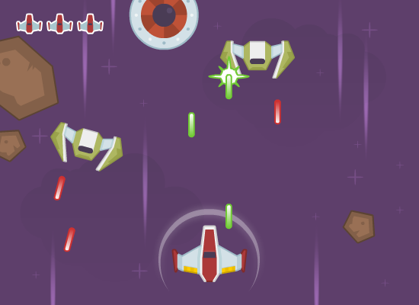

How do you plan to make your game engaging?

ADDING A TIME LIMIT TO GAME. SPAWNING METEORITES WHICH CAN DESTROY USER SHIP. INCREASING HP OF ENEMY SHIPS SO IT TAKES MULTIPLE SHOTS TO KILL THEM.